Application Number | 07/2017/1150/FUL
Address | 15 Preston Road  Leyland  Lancashire  PR25 4NT
Applicant  Agent | Mr Nabeel Tabarik  Mr Lukman Vika  Daisyfield Business Centre  Suite 301  Appleby Street  Blackburn  BB1 3BL
Development | Change of Use of Ground Floor from housing multiple occupation (Sui Generis) to (Class A5) Hot Food Takeaway including New Shop Front and Siting of New Extractor Flue to Rear
Officer Recommendation Officer Name | Approval  Mrs Catherine Lewis
Date application valid | 02.05.2017
Target Determination Date | 27.06.2017
Extension of Time | 19.10.2017
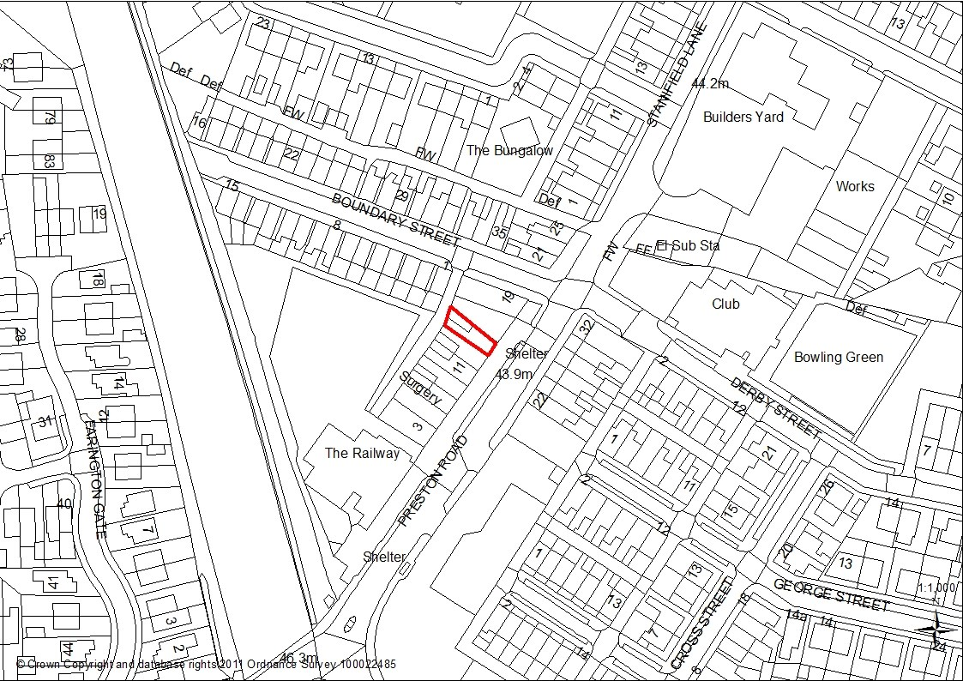

1.0 Introduction
1.1This application is being presented to Committee because the proposal is for change of use to a hot food take away; a use outside the scheme of delegation.

2.0 Report Summary
2.1 The proposal for a change of use of a three storey mid terrace property in multiple occupation to a hot food takeaway within the District Centre of Farington is not considered to have any detrimental impact on existing uses within the District Centre, including neighbouring residential use and is considered to accord with Policy E5 of the South Ribble Local Plan. The application is therefore recommended for approval.

3.0Site and Surrounding Area
3.1 The application site relates to a three storey mid terrace property in multiple occupation (HMO) on Preston Road in Farrington.
3.2 The site falls within the boundary of the Farrington Local Centre as identified by the Policies Map that accompanies the South Ribble Local Plan 2015. To the rear there is a narrow access alley leading off Boundary Street. Commercial properties exist to either side of the application property, some with residential apartment above. Neighbouring properties include a number of takeaway premises, a Turkish takeaway, Chinese takeaway, an art studio, hair salon and a tandorri with a bridal shop and cycle store at either end of the row.
3.3 Residential properties are also located on the opposite side of Preston Road.

4.0 Planning History
4.1 07/2002/0416: Change of use from shop (Class A1) to hot food takeaway (Class A3) Approved
4.2 07/2011/0250/FUL: Change of use from Class C2 residential ground floor flat to Class A1 hair salon including the installation of a new shop front and roller shutters. Approved.

5.0 Proposal
5.1 The proposal involves a change of use of the ground floor (HMO) to a hot food takeaway including a new shop front and the siting of an extractor flue to the rear. Currently the ground floor is used as residential accommodation, but above the window there is a fascia board to the front elevation. A new door would be added to the shop front and the proposal would provide for an aluminium powder coated fame to be matt back in colour with perforated roller shutters. The shutter box would be internally mounted behind the fascia panel. The fascia panel above the front window would be compressed laminate board to be black in colour.
5.2 The flue to the rear would be 400mm in diameter and constructed of galvanised steel fixed with brackets to the rear.
5.3 Hours of operation 11:00 am to 23:00 hours every day including Sundays and Bank Holidays.

6.0 Summary of Documents Submitted
- Design and Access Statement
- Ventilation and Extraction Statement
- Extract Canopy Calculations
- Waste and Recycling Statement

7.0 Summary of Publicity
7.1 Neighbouring properties were notified and a site notice posted with 2 letters of representation being received. The comments are summarised below:
7.2 Letters of objection
- Object to more fast food outlets due to loss of community based businesses
- Limited car parking available
- Impact of increase number of fast food outlets within the wider area • Risk of fire.

8.0 Summary of Consultations
8.1 Environmental Health: Initially, objected to the proposal due to insufficient information being presented about the impact on neighbouring residential properties including the above flats. The development has the potential to adversely affect the amenity of neighbouring properties. Further detail are required on odour control, disposal of liquid waste, disposal of waste associated with the above flats, confirmation of the full 60 minute fire protection between the takeaway and the flats is required and a sound insulation test between the shop and flats would be required. Additional information has been submitted which seeks to address these concerns and the EHO is satisfied with the revised noise report, ventilation and disposal of commercial waste details.
8.2 County Highways: Raise no objection and consider that the proposals would have a negligible impact upon highway safety and highway capacity in the immediate vicinity of the site.
8.3 Police Liaison Officer. Over the past 12 months the area has experienced high levels of crime and antisocial behaviour. Incidents have been recorded including burglary, criminal damage, vehicular crime and assaults together with shop staff assaulted. A number of measures are requested as conditions or an advisory note to any planning permission. 9.0 Policy Background

NPPF
Paragraph 58 Create a safe and accessible environments where crime and disorder and the fear of crime do not undermine the quality of life or community cohesion.

Central Lancashire Core Strategy
Policy 17 Design of New Buildings
Policy 26 Crime and Community Safety
South Ribble Local Plan Policy E5 Local Centres
Policy G17 Design Criteria in new Development.
10.0 Material Considerations

10.1 Local Plan Allocation
The application site is located within the Farington Local Centre as defined in Policy E5 of the South Ribble Local Plan.
The Policy States:
Within the Local Centres A1 (Retail) uses will be protected and enhanced wherever possible in order to achieve a minimum of 60%. This is to maintain the vitality and viability of the centre.
Applications for other local uses including A2 (Financial and Professional Services) A3 Cafes and Restaurants and A4 Drinking Establishments, an dB1 (offices) may be appropriate where it does not undermine the sustainability of the shopping areas
The application site is currently a Home of Multiple Occupation and as such would not involve the loss of an existing A1 retail use. Therefore, the change of use would in principle be acceptable.

10.2 Design
10.2.1 A new door would be added to the shop front and the proposal would provide for an aluminium powder coated frame to be matt back in colour with perforated roller shutters. The shutter box would be internally mounted behind the fascia panel. The fascia panel above the front window would be compressed laminate board to be black in colour. These details are not dissimilar to the other shop units and the opportunity to reinstate a shop front within the existing parade of shops is strongly supported. The details are considered acceptable and meet the aims of Policy G17 of the South Ribble Local Plan.
10.2.2 The applicant has advised that details of signage would be the subject of a separate advertisement application if required.

10.3 Highways and Parking
10.3.1 The frontage of the application site faces on to Preston Road where a bus stop and a pedestrian crossing are present. Although there is no specific on street car parking Lancashire County Council Highways section has raised no objection to the proposal and is of the opinion that the proposal would have a negligible impact on highway safety and highway capacity within the immediate vicinity of the site. The proposal is considered acceptable in terms of highway safety and amenity.
10.4 Relationship to Neighbours and Impact upon the character of the area.
10.4.1 In terms of residential amenity Policy 17 in the Central Lancashire Core Strategy requires new development to be sympathetic to surrounding land uses and occupiers and avoid demonstrable harm to the amenities of the local area. Farington Local Centre consists of two distinct locations and between these two designated areas there are four groups of terraced properties most of which are residential. There is a row of residential properties opposite the application site but as there are already hot food takeaways within the same parade of shops the impacts of the development have been previously assessed and found acceptable. The hours of operation are also consistent with similar uses and provided that there is a condition controlling them the proposal therefore complies with Policy G17 of the South Ribble Local Plan.

10.5 Noise and Odour
10.5.1 The application provides for an external flue to be constructed to the rear of the property. Initially Environmental Health raised concerns that the proposal would have the potential to adversely impact upon the residents in terms of noise, disturbance and odour. Revised information and plans have been received which demonstrate an improved design of the extraction system, a noise report and ventilation and disposal of waste details.
The information has been fully assessed by Environmental Health Officers who have confirmed that the submitted information is acceptable. Questions have been raised about the waste arrangements for the flats but this aspect does not form part of the current application. Nevertheless, the applicant has advised that a private contractor would manage the waste for the residential flats.

10.6 Crime and Disorder
10.6.1 A Crime Impact Statement has been provided by the Police which advised that there have been high levels of crime and antisocial behaviour recorded -as incidents as Hot Food takeaways are often flash points for antisocial behaviour, crime risks need to be reduced where possible through design. A number of recommendations have been made which include glazing, rear boundary treatment, illumination, CCTv installation, waste bins and fire precautions. This information has been forwarded to the applicant for their consideration.

10.7 Other matters
10.7.1 Two letters of representation have been received which express concerns about the increase in the number of hot food takeaway within the area. The National Planning Policy Framework make clear that local planning authorities should focus on whether the development itself is an acceptable use of the land and the impact of the use, rather than the control of processes or emissions themselves where these are subject to approval under pollution control regimes. As the site is located within the Farington District Centre and has previously been approved as a Hot Food takeaway the proposal is considered acceptable.

11.0 CONCLUSION
11.1 The proposed change of use of the ground floor property from a unit in multiple occupation to a hot food takeaway would provide the opportunity to reinstate a shop front within the existing parade of shops and is strongly supported. The change of use accords with Policy E5 and G17 of the South Ribble Local Plan. The proposal is therefore recommended for approval subject to the imposition of conditions.

RECOMMENDATION:
Approval.
RECOMMENDED CONDITIONS:
- The development hereby permitted must be begun not later than the expiration of three years beginning with the date of this permission.
REASON: Required to be imposed pursuant to Section 91 of the Town and Country Planning Act 1990.
- The development, hereby permitted, shall be carried out in accordance with the approved plans
Drawing Number 01A entitled Existing and Proposed Plans and Elevations Drawing Number 02A entitled Existing and Proposed Elevations
or any subsequent amendments to those plans that have been agreed in writing by the Local Planning Authority.
REASON: For the avoidance of doubt and to ensure a satisfactory standard of
development
- The details submitted in the Ventilation and Extraction System Version V3, Amended (28/09/2017) shall be implemented in full before the use is commenced.
REASON: To protect the residential amenity of the surrounding area.
- The details submitted in the Waste Statement Version V3, Amended (28/09/2017) shall be implemented in full before the use is commenced.
REASON: To protect the residential amenity of the surrounding area
- The details submitted in the document entitled Environmental Assessment Rev1 July 2017 by AB Acoustics shall be implemented in full before the use is commenced.
REASON: To protect the residential amenity of the surrounding area
- The use of the premises hereby approved shall be restricted to hours of operation 11:00 am to 23:00 hours every day including Sundays and Bank Holidays.
REASON: In the interests of the amenities of adjoining residents and to accord with Policy 17 in the Central Lancashire Core Strategy

RELEVANT POLICY
NPPF National Planning Policy Framework
POLB1 Existing Built-Up Areas
POLE5 Local Centres

POLG17 Design Criteria for New Development

